**Lecture1,2 and 3**

Topics to Be Covered:

* Introduction
* Definition
* Goals of Operating System
* History
* Operation /Functions of OS
* Types of Operating System

**Introduction**

An **Operating system (OS)** is software which acts as an interface between the end user and computer hardware. Every computer must have at least one OS to run other programs. An application likes Chrome, MS Word, Games, etc needs some environment in which it will run and perform its task. The OS helps you to communicate with the computer without knowing how to speak the computer's language. It is **not** possible for the user to use any computer or mobile device without having an operating system.

An operating system acts as an intermediary between the user of a computer and computer hardware. The purpose of an operating system is to provide an environment in which a user can execute programs in a convenient and efficient manner.

An operating system is software that manages the computer hardware. The hardware must provide appropriate mechanisms to ensure the correct operation of the computer system and to prevent user programs from interfering with the proper operation of the system.

**Definition:**

* An operating system is a program that controls the execution of application programs and acts as an interface between the user of a computer and the computer hardware.
* A more common definition is that the operating system is the one program running at all times on the computer (usually called the kernel), with all else being application programs.
* An operating system is concerned with the allocation of resources and services, such as memory, processors, devices, and information. The operating system correspondingly includes programs to manage these resources, such as a traffic controller, a scheduler, memory management module, I/O programs, and a file system.

Some popular Operating Systems include Linux Operating System, Windows Operating System, Salaries, VMS, OS/400, AIX, z/OS, etc.

**Goals of Operating system**

1. **Convenience:** An OS makes a computer more convenient to use.
2. **Control and Manage Resource:** An OS allows the computer system resources to be used in an efficient manner.
3. **Ability to Evolve:** An OS should be constructed in such a way as to permit the effective development, testing and introduction of new system functions at the same time without interfering with service.

Operating system as User Interface –

1. User
2. System and application programs
3. Operating system
4. Hardware

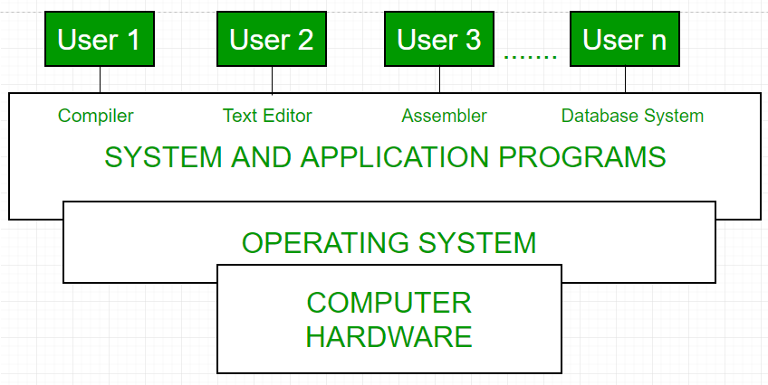Fig1.1: Conceptual view of a computer system

Every general-purpose computer consists of the hardware, operating system, system programs, and application programs. The hardware consists of memory, CPU, ALU, and I/O devices, peripheral device, and storage device. System program consists of compilers, loaders, editors, OS, etc. The application program consists of business programs, database programs

Every computer must have an operating system to run other programs. The operating system coordinates the use of the hardware among the various system programs and application programs for various users. It simply provides an environment within which other programs can do useful work.

The operating system is a set of special programs that run on a computer system that allows it to work properly. It performs basic tasks such as recognizing input from the keyboard, keeping track of files and directories on the disk, sending output to the display screen and controlling peripheral devices

**OS is designed to serve two basic purposes:**

1. It controls the allocation and use of the computing System’s resources among the various user and tasks.

2. It provides an interface between the computer hardware and the programmer that simplifies and makes feasible for coding, creation, debugging of application programs

**History of Operating System**

Operating system has been evolving through the years.

The first computers did not have operating systems. Each program that was running on these first computers had to include all the code needed to run on the computer, communicate with the connected hardware and perform the calculation that the program was intended to perform. This situation made even the simplest programs become very complex.

In response to this problem, the owners of the central computers began to develop system software that facilitated the writing and execution of the programs included in the computer, and thus the first operating systems were born.

The first operating system was created by General Motors in 1956 to run a single IBM central computer. In the 1960s, IBM was the first computer manufacturer to take on the task of developing operating systems and began distributing operating systems included in its computers.

The first operating systems were developed in the 1950s, when computers could only run one program at a time. Later in the following decades, computers began to include more and more software programs, sometimes called libraries, that came together to create the start of today’s operating systems.

In the late 1960s, the first version of the Unix operating system was developed. Written in programming language C, and available for free during its early years. Unix easily adapted to the new systems and quickly achieved wide acceptance.

Many modern operating systems, including Apple OS X and all different versions of Linux, date back or rely on the Unix OS.

Microsoft Windows was developed in response to an IBM request for an operating system to run its range of personal computers or PCs.

The first operating system created by Microsoft was not called Windows, it was called MS-DOS and it was built in 1981 when it bought the 86-DOS operating system from Seattle Computer Products and modified it to meet IBM requirements.

The Windows name was first used in 1985 when a graphical user interface was created and paired or joined with the MS-DOS.

Today Apple, OS X, Microsoft Windows and the various forms of Linux (including Android) dominate the vast majority of the modern operating systems market, as we saw earlier.

**Operation / Function of Operating System**

Following are some of important functions of an operating System.

* Memory Management
* Processor Management
* Device Management
* File Management
* Security
* Control over system performance
* Job accounting
* Error detecting aids
* Coordination between other software and users

**i)Memory Management**

Memory management refers to management of Primary Memory or Main Memory. Main memory is a large array of words or bytes where each word or byte has its own address.

Main memory provides a fast storage that can be accessed directly by the CPU. For a program to be executed, it must in the main memory. An Operating System does the following activities for memory management −

* Keeps tracks of primary memory, i.e., what part of it are in use by whom, what part are not in use.
* In multiprogramming, the OS decides which process will get memory when and how much.
* Allocates the memory when a process requests it to do so.
* De-allocates the memory when a process no longer needs it or has been terminated.

**ii) Processor Management**

In multiprogramming environment, the OS decides which process gets the processor when and for how much time. This function is called **process scheduling**. An Operating System does the following activities for processor management −

* Keeps tracks of processor and status of process. The program responsible for this task is known as **traffic controller**.
* Allocates the processor (CPU) to a process.
* De-allocates processor when a process is no longer required.

iii) Device Management

An Operating System manages device communication via their respective drivers. It does the following activities for device management −

* Keeps tracks of all devices. Program responsible for this task is known as the **I/O controller**.
* Decides which process gets the device when and for how much time.
* Allocates the device in the efficient way.
* De-allocates devices.

iv) File Management

A file system is normally organized into directories for easy navigation and usage. These directories may contain files and other directions.

An Operating System does the following activities for file management −

* Keeps track of information, location, uses, status etc. The collective facilities are often known as **file system**.
* Decides who gets the resources.
* Allocates the resources.
* De-allocates the resources.

**Other Important Functions**

Following are some of the important functions that an Operating System performs −

* **Security** − By means of password and similar other techniques, it prevents unauthorized access to programs and data.
* **Control over system performance** − Recording delays between request for a service and response from the system.
* **Job accounting** − Keeping track of time and resources used by various jobs and users.
* **Error detecting aids** − Production of dumps, traces, error messages, and other debugging and error detecting aids.
* **Coordination between other softwares and users** − Coordination and assignment of compilers, interpreters, assemblers and other software to the various users of the computer systems.

# Types of Operating System

## 1. Batch operating system

The users of a batch operating system do not interact with the computer directly. Each user prepares his job on an off-line device like punch cards and submits it to the computer operator. To speed up processing, jobs with similar needs are batched together and run as a group. The programmers leave their programs with the operator and the operator then sorts the programs with similar requirements into batches.

The problems with Batch Systems are as follows −

* Lack of interaction between the user and the job.
* CPU is often idle, because the speed of the mechanical I/O devices is slower than the CPU.
* Difficult to provide the desired priority.

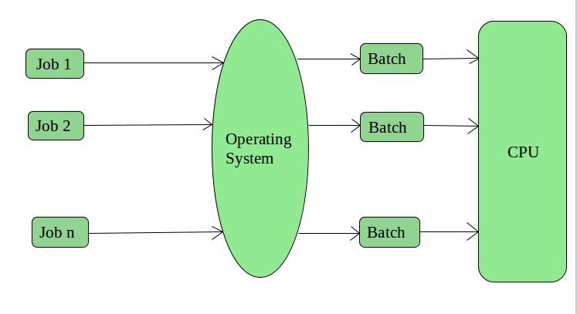

Fig1.2 Batch Operating System

## 2. Multiprogramming operating system

Sharing the processor, when two or more programs reside in memory at the same time, is referred as **multiprogramming**. Multiprogramming assumes a single shared processor. Multiprogramming increases CPU utilization by organizing jobs so that the CPU always has one to execute.

The following figure shows the memory layout for a multiprogramming system.

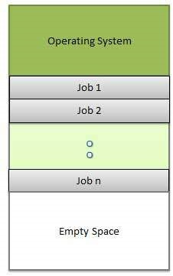

Fig 1.3 Multiprogramming operating system

An OS does the following activities related to multiprogramming.

* The operating system keeps several jobs in memory at a time.
* This set of jobs is a subset of the jobs kept in the job pool.
* The operating system picks and begins to execute one of the jobs in the memory.
* Multiprogramming operating systems monitor the state of all active programs and system resources using memory management programs to ensures that the CPU is never idle, unless there are no jobs to process.

### Advantages

* High and efficient CPU utilization.
* User feels that many programs are allotted CPU almost simultaneously.

### Disadvantages

* CPU scheduling is required.
* To accommodate many jobs in memory, memory management is required.

## 3. Time-sharing/ Multitasking operating systems

## Each task is given some time to execute, so that all the tasks work smoothly. Each user gets time of CPU as they use single system. These systems are also known as Multitasking Systems. The task can be from single user or from different users also. The time that each task gets to execute is called quantum. After this time interval is over OS switches over to next task.

Time-sharing is a technique which enables many people, located at various terminals, to use a particular computer system at the same time. Time-sharing or multitasking is a logical extension of multiprogramming. Processor's time which is shared among multiple users simultaneously is termed as time-sharing.

The main difference between Multiprogrammed Batch Systems and Time-Sharing Systems is that in case of Multiprogrammed batch systems, the objective is to maximize processor use, whereas in Time-Sharing Systems, the objective is to minimize response time.

Multiple jobs are executed by the CPU by switching between them, but the switches occur so frequently. Thus, the user can receive an immediate response. For example, in a transaction processing, the processor executes each user program in a short burst or quantum of computation. That is, if **n** users are present, then each user can get a time quantum. When the user submits the command, the response time is in few seconds at most.

The operating system uses CPU scheduling and multiprogramming to provide each user with a small portion of a time. Computer systems that were designed primarily as batch systems have been modified to time-sharing systems.

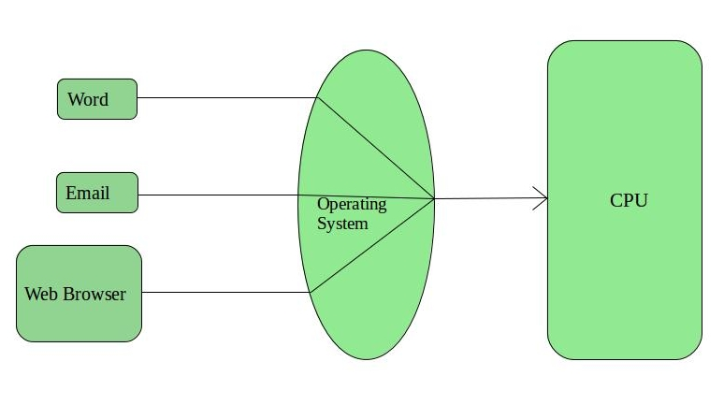

Fig1.4 Time sharing operating system

.

**Advantages of Timesharing operating systems** are as follows −

* Provides the advantage of quick response.
* Less chances of duplication of software

Reduces CPU idle

**Disadvantages of Time-sharing operating systems** are as follows −

* Problem of reliability.
* Question of security and integrity of user programs and data.

**Part A**

1. Define operating system
2. Goals of operating system
3. When was the first operating system was created and by whom?
4. The first operating system created by Microsoft was known as?
5. What are the main operations perform by operating system
6. What was the problem associated by Batch operating system?
7. Explain the term multiprogramming
8. What are the main features of timesharing operating system?

**Part B**

01: What is an operating system? What are the services offered by the operating system?

Explain all of them in detail. (RTU-2016)

02: What are the features of timesharing operating system?

03: Write short note on early operating system.

Q.4 What are the five major activities of an OS with regard to file management? (RTU-16)

Q.5 Explain the various services that are provided by operating system in brief. (RTU-2013)

Q.6 Explain the following operating system in detail

i) Batch operating system

ii) Multiprogramming operating system

iii) Timesharing operating system